CC2101 Software Engineering Assignment 1



School of Systems and Technology UMT Lahore Pakistan

NAME: NIMRA FAYSAL
ROLL NO F2024065140
SECTION: W8
SOFTWARE ENGINEERING

PROJECT NAME:

SECURE CONTACT LOG

PROTOTYPES:
SCREENSHOT:

SIGN IN:
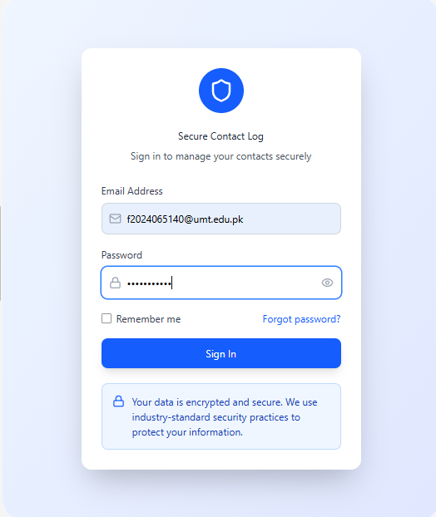

DASHBOARD:

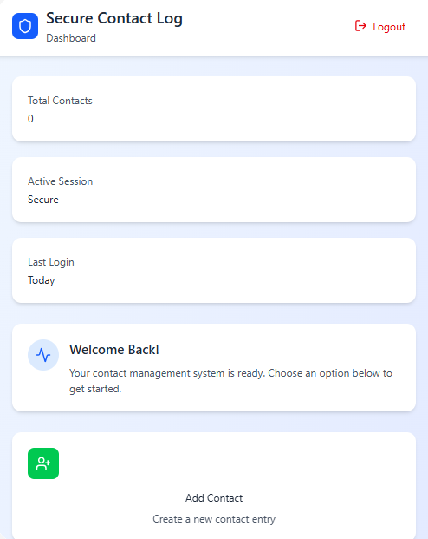

ADDING INFORMATION AND CREATING CONTACT:

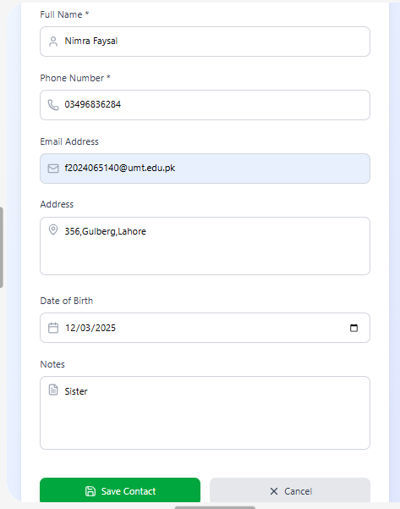

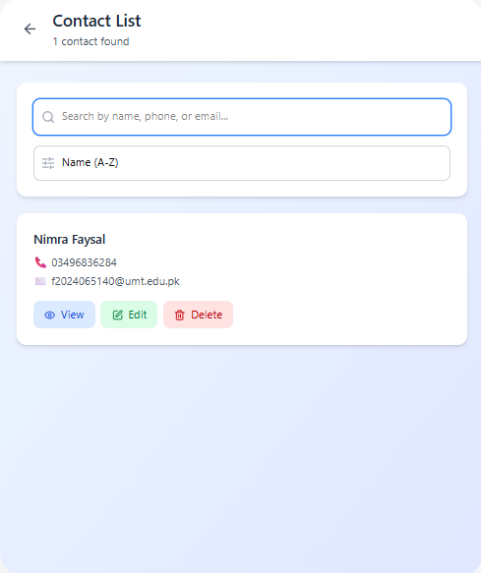
SAVING THE CONTACT :
VIEW MODE:

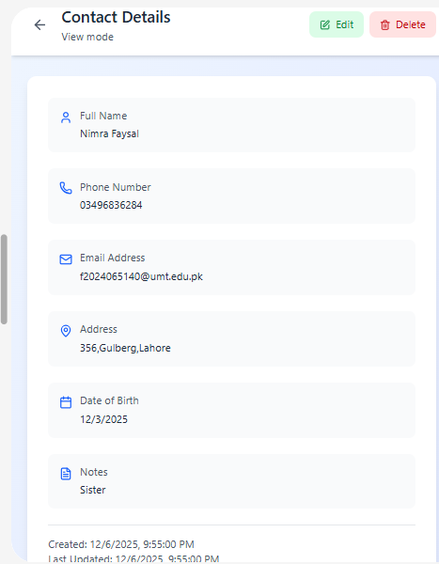

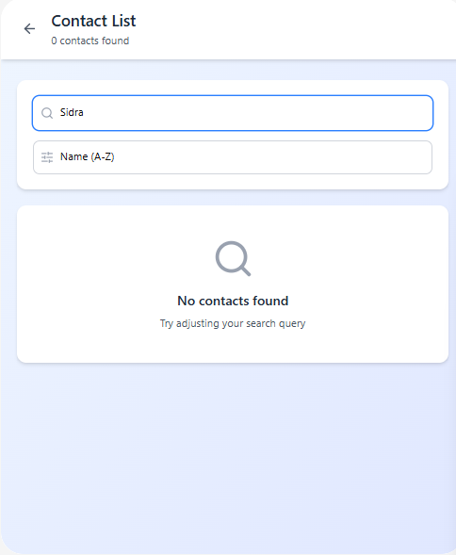
NO OTHER NAMES FOUND:
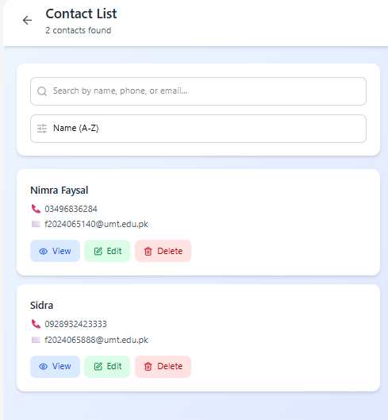
EDIT CONTACT LIST:

LINK OF PROTOTYPES:

https://www.figma.com/make/9QRZDXXMdYb9qkOiUuHFBY/Secure-Contact-Log-Prototypes?t=ixZ762wNMq03uqEo-20&fullscreen=1

